**Lab 19**

**Student Name: Navneet P**

**Student ID: AF0411619**

*Topic – Numpy Statistical Functions*

Functions used in this assignment: -

1. **numpy.mean()**: Calculates the average (arithmetic mean) of the elements in an array along a specified axis
2. **numpy.median()**: Computes the median (middle value) of the elements in an array, which separates the higher half from the lower half.
3. **numpy.std()**: Computes the standard deviation, a measure of the amount of variation or dispersion of a set of values in an array.
4. **astype()**: Converts the data type of a NumPy array to a specified type (e.g., from float64 to float32).
5. **numpy.genfromtxt()**: Loads data from a text file, with support for handling missing values and specifying data types for each column.
6. **numpy.isnan()**: Checks whether each element in an array is NaN (Not a Number) and returns a boolean array indicating the presence of NaN values.
7. **numpy.savetxt()**: Saves an array to a text file in a specified format, allowing for control over delimiters and headers.

Q1. How to find the mean of every NumPy array in the given list?

Input: list = [ np.array([3, 2, 8, 9]), np.array([4, 12, 34, 25, 78]), np.array([23, 12, 67]) ]

Solution:

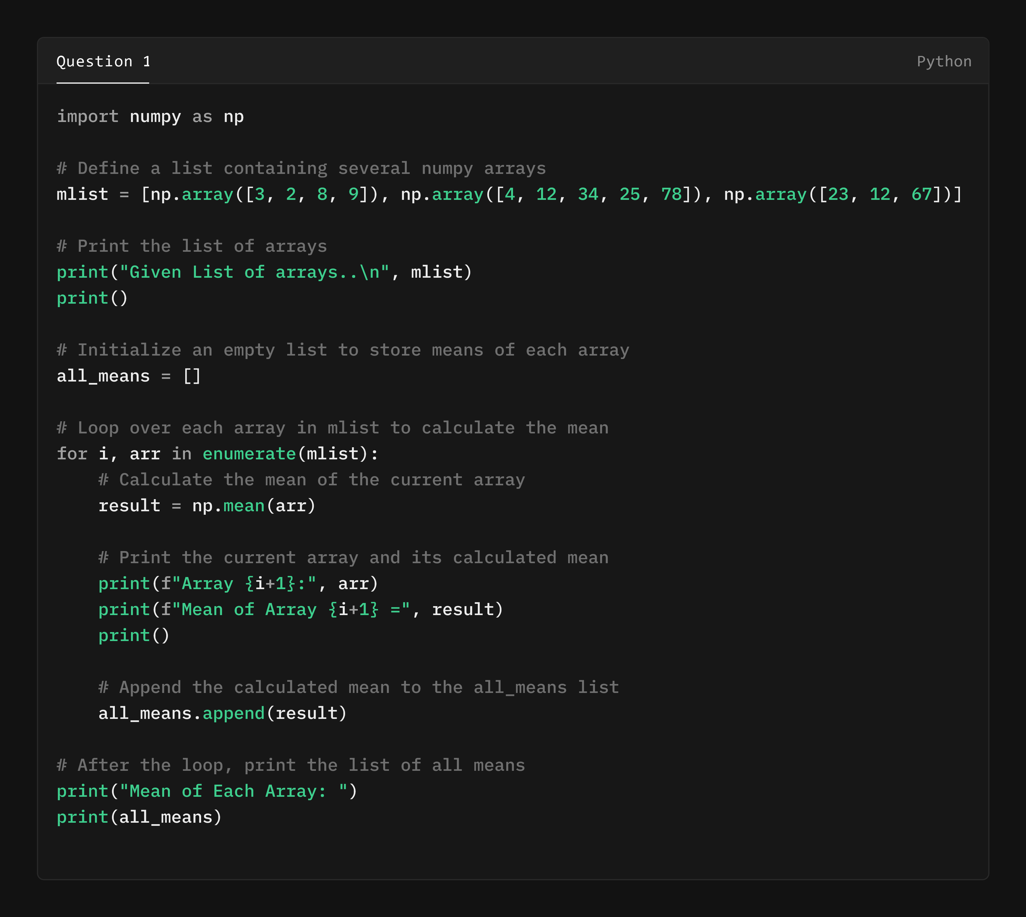

Output:

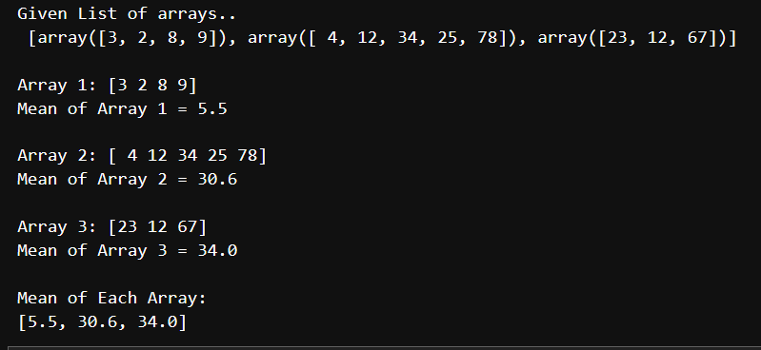

Q2.  Compute the median of the flattened NumPy array Input: x_odd = np.array([1, 2, 3, 4, 5, 6, 7])

Solution:

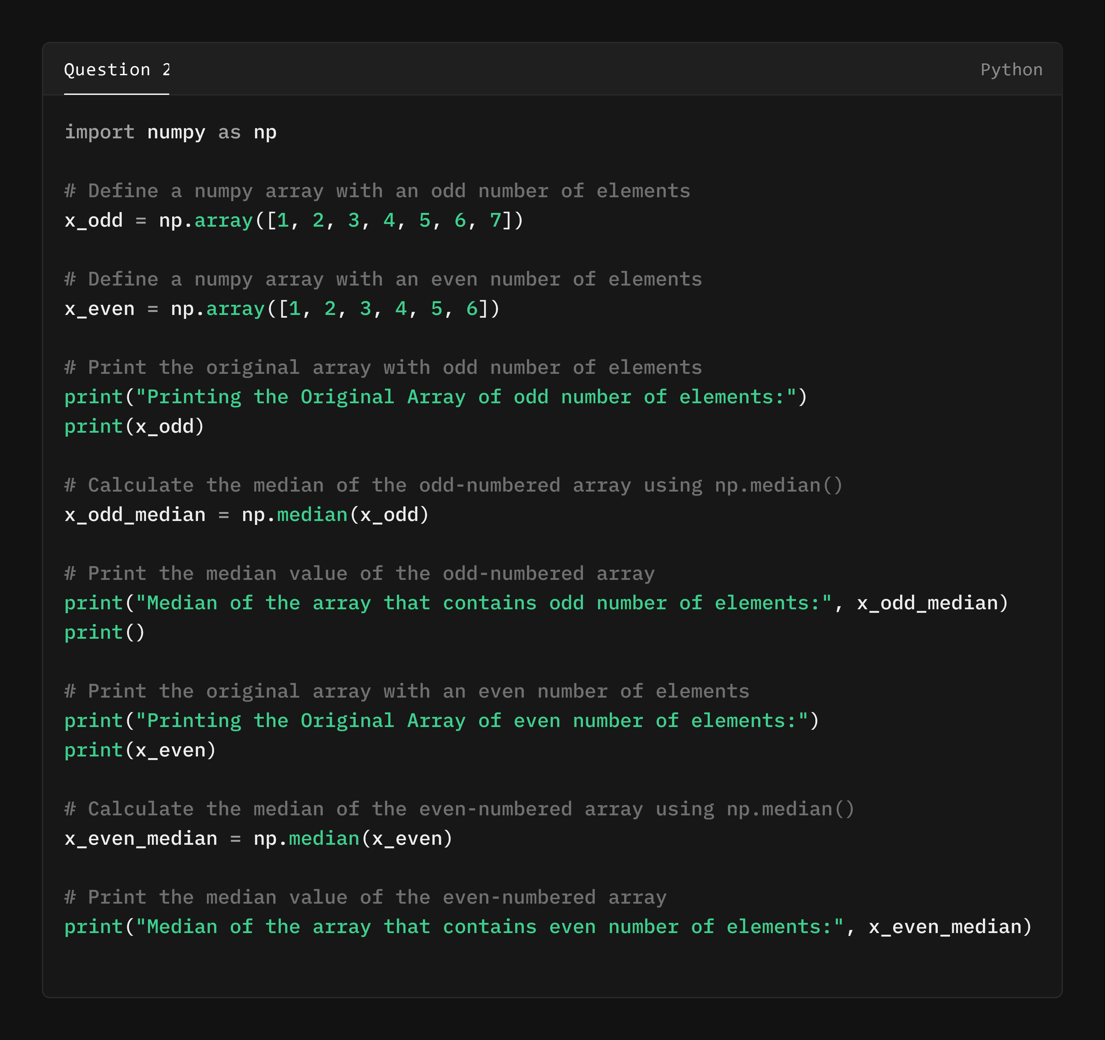

Output:

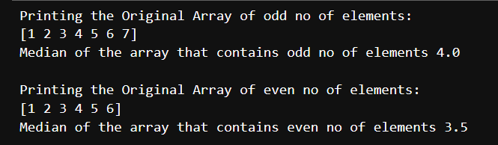

Q3. Compute the standard deviation of the NumPy array Input: arr = [20, 2, 7, 1, 34]

Solution:

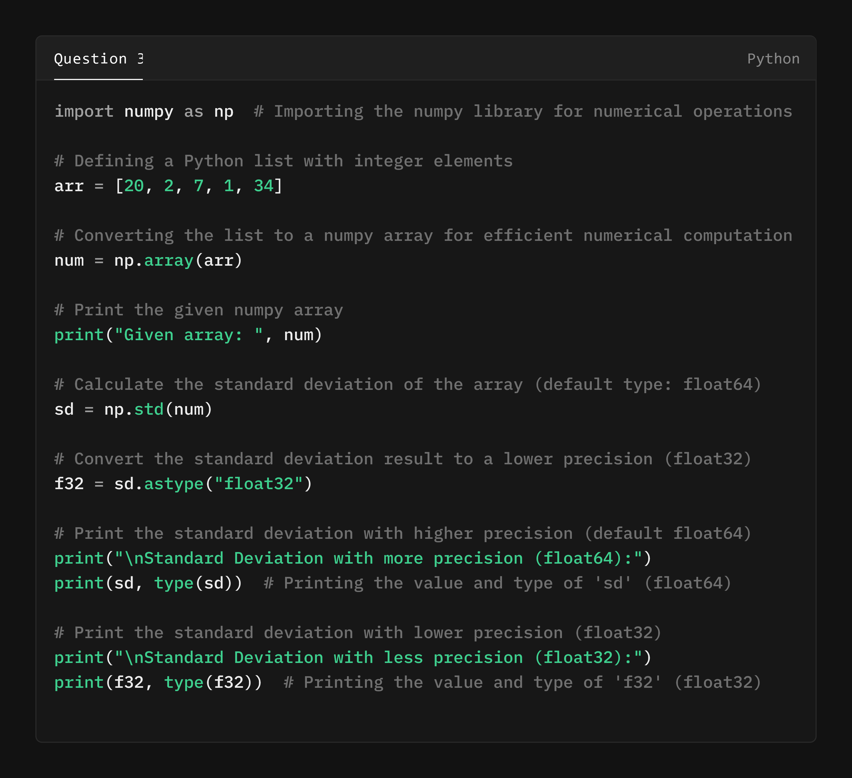

Output:

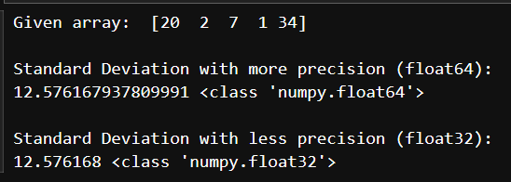

Q4. Suppose you have a CSV file named 'house_prices.csv' with price information, and you want to perform the following

operations:

1. Read the data from the CSV file into a NumPy array.

2. Calculate the average of house prices.

3.Identify house price above the average.

4.Save the list of high prices to a new CSV file. Note: Download 'house_prices.csv' file from LMS.

Solution:

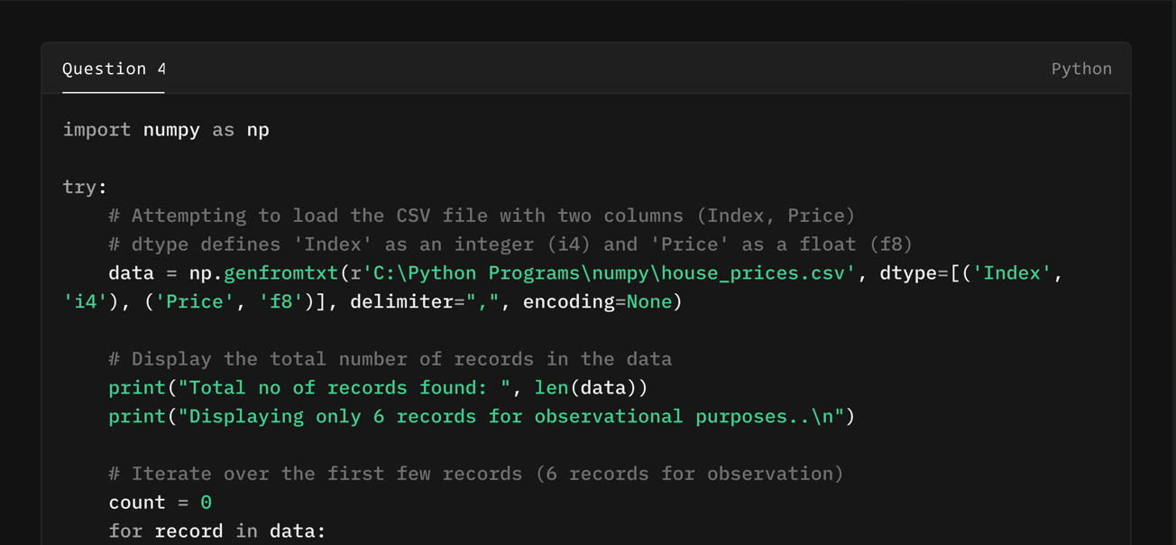

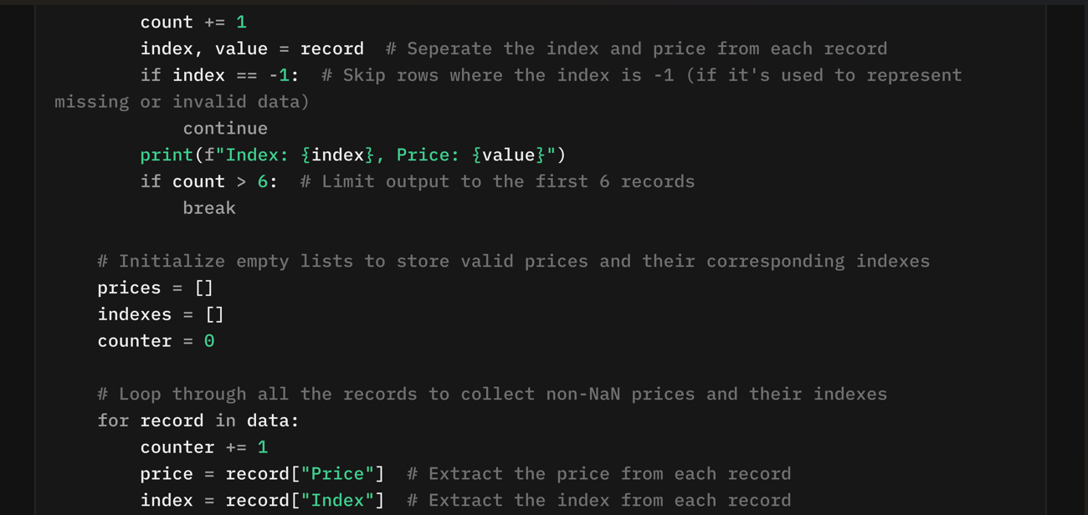

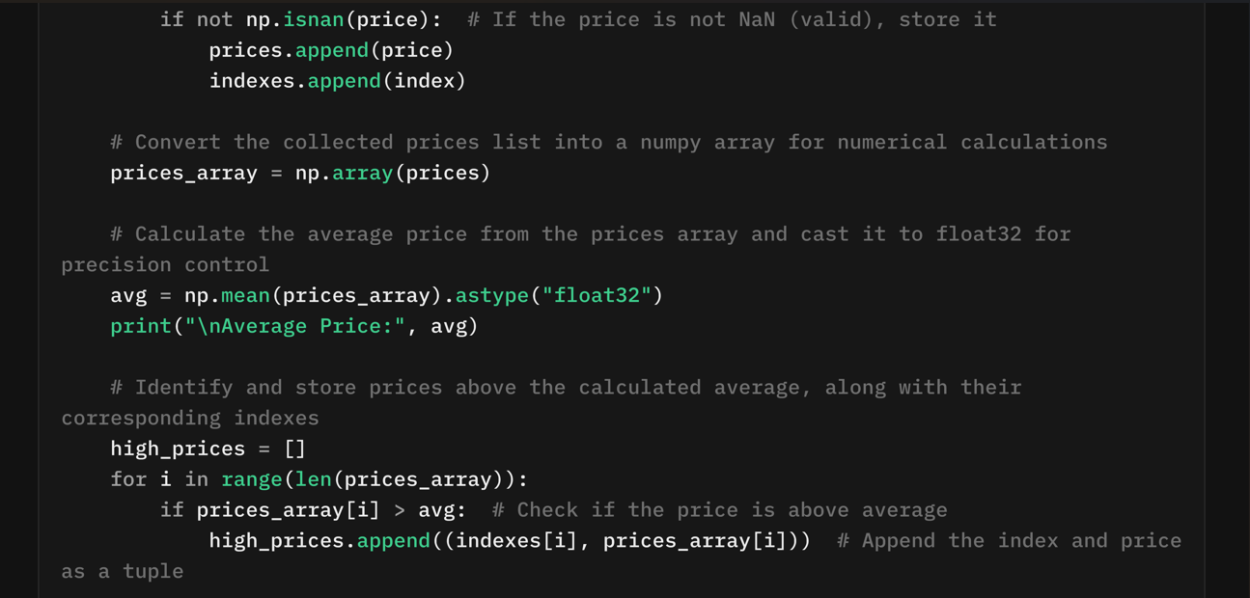

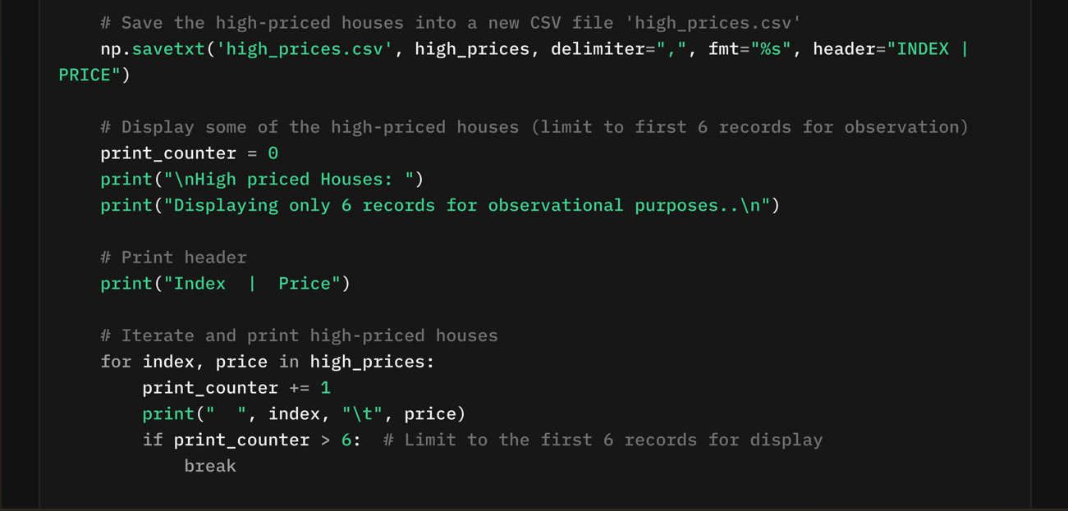

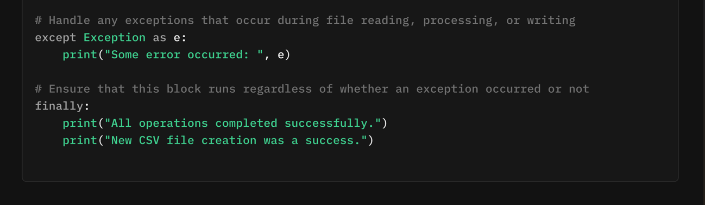

Output:

